**Final Project Report - AI for Developers**

**Eman yaghmour**

**1. Introduction**

This project is a simple AI application that generates text or images using **OpenAI API**. It allows users to input textual instructions and receive AI-generated responses either as text via **GPT-4** or as images via **DALL·E**.

**2. Technical Requirements**

**2.1 Tools and Technologies Used**

* **Programming Language**: Python
* **Libraries Used**:
  + openai - for utilizing OpenAI API
  + flask - for creating a simple web interface
  + 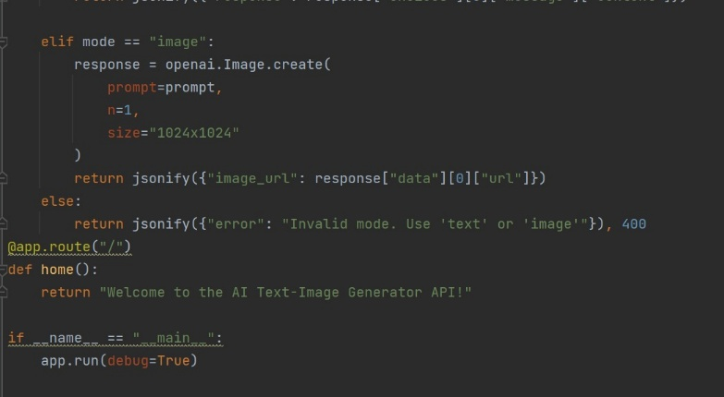A screen shot of a computer program

    Description automatically generatedrequests - for sending API requests
* **Development Environment**:
  + Visual Studio Code
  + GitHub Copilot for coding assistance
* **GitHub Repository**:
  + 🔗 <https://github.com/Emanyagmor/AI-Text-Image-Generator.git>

**3. Implementation Stages**

**3.1 Setting Up the Environment**

1. Install the required libraries using:

pip install openai flask requests

1. Create a app.py file for the main script.

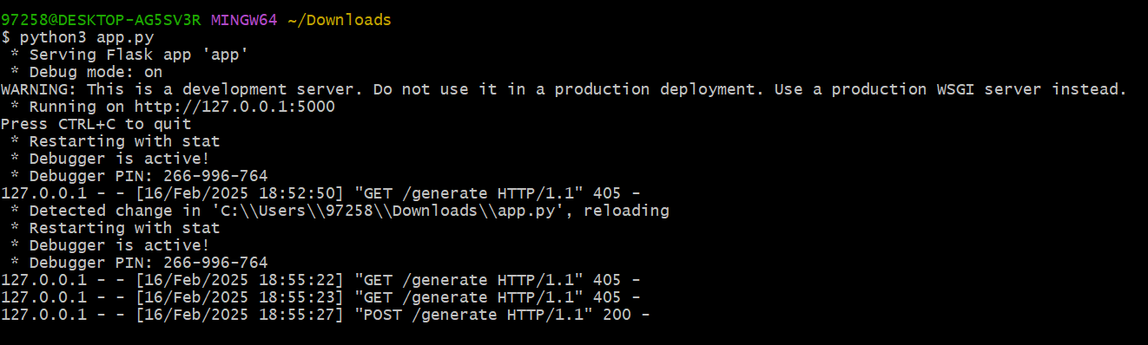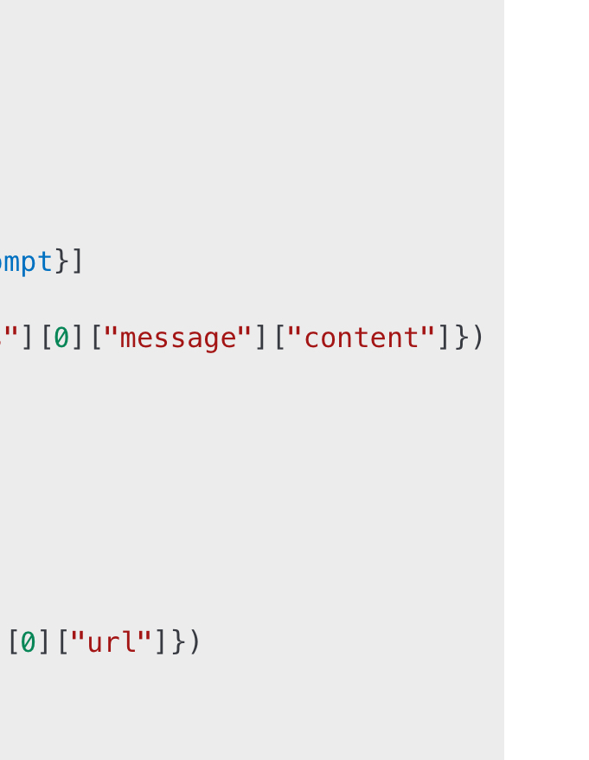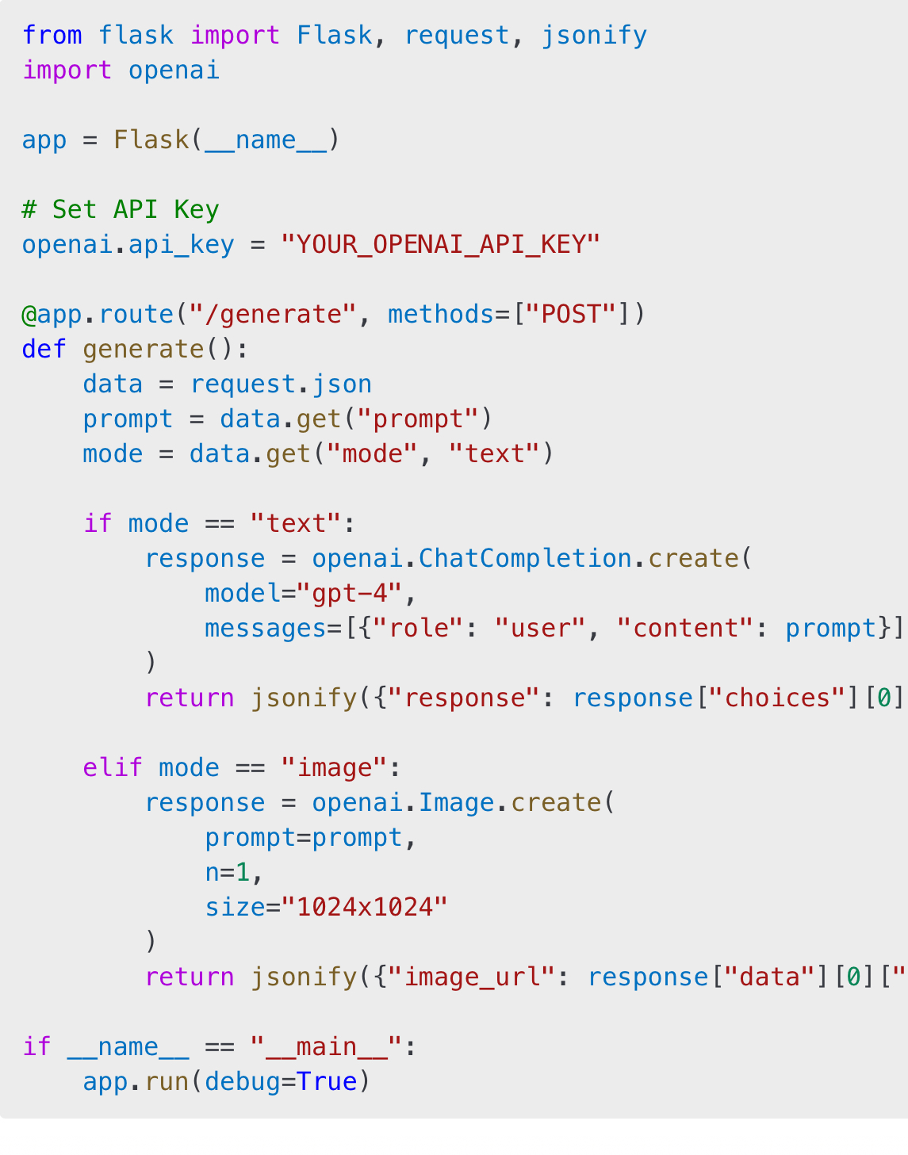**3.2 Core Code**

**4. Running and Testing the Application**

**4.1 Running Locally**

1. Start the server using:

python app.py

1. Send a request using Postman or curl:

curl -X POST http://127.0.0.1:5000/generate -H "Content-Type: application/json" -d '{"prompt": "Write a short story", "mode": "text"}'

1. Receive a generated text or an image when using mode="image".

**5. Conclusions and Challenges**

**5.1 Achievements**

✅ Successfully implemented the application. ✅ Effectively utilized GitHub Copilot. ✅ Documented the process in this report.

**6. Final Deliverables**

* 📂 **Project files uploaded to GitHub**.
* 📜 **This report contains all details and screenshots**.

🚀 **Thank you! You can check out the repository and try the application yourself**